Starters Guide – Programming Alice 2.2 in Visual Studio 2008
Requirements:
- Visual Studio 2008
- Alice 2.2 source code
- Latest version of Alice 2.2 from http://alice.org/index.php?page=downloads/download_alice2.2#

Creating a project in Visual Studio 2008
- Create a new Project.
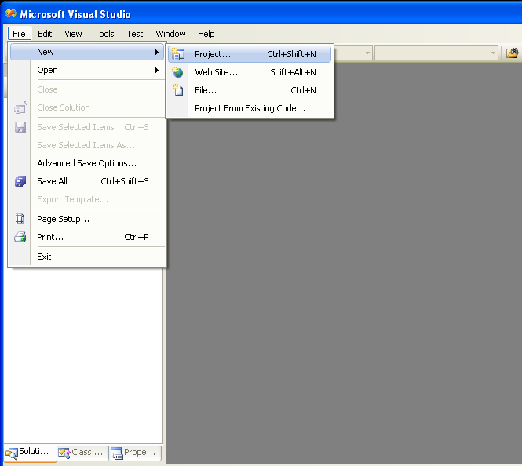
- Select Empty Project from the Visual C++, General section, and then name your project.
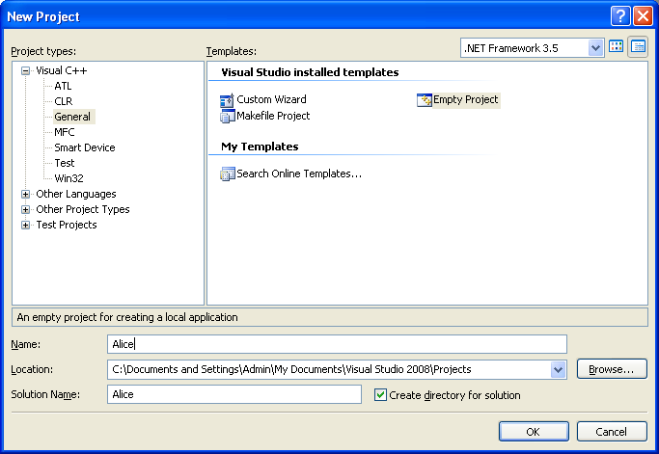
- Once your project is created, you will see three folders labeled Header Files, Resource Files, and Source Files. Right click on the Source Files folder, select Add and click Existing Item.
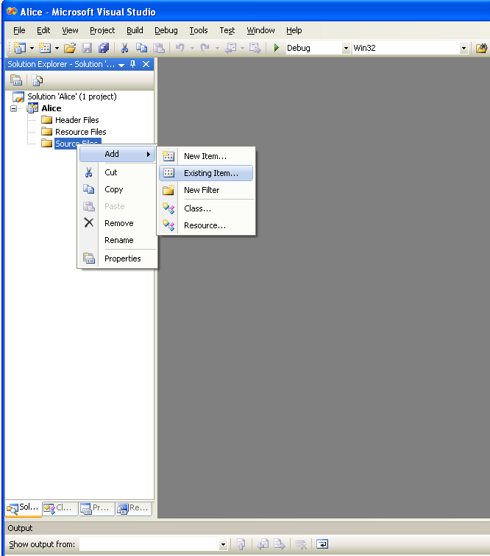
- Browse to your Alice 2.2 Source folder and add launcher.cpp to your Alice project.
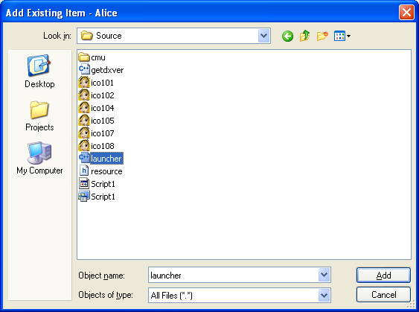
- Right click on the Resource Files folder, select Add and click Existing Item.
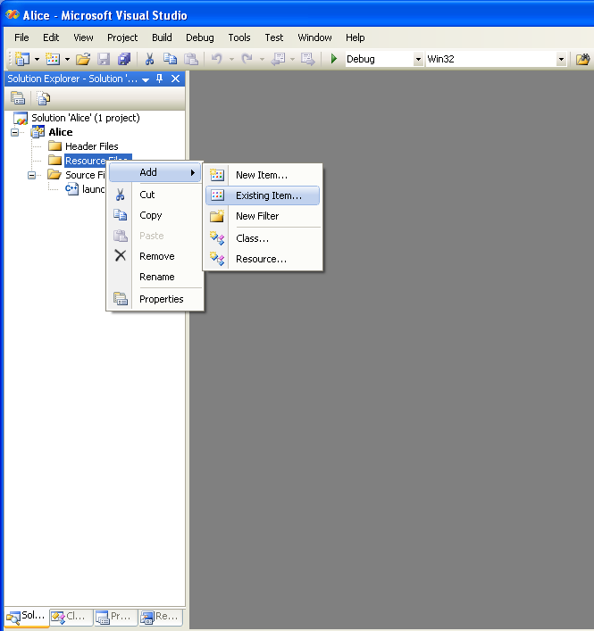
- Browse to your Alice 2.2 Source folder and add Script1.rc to your Alice project.
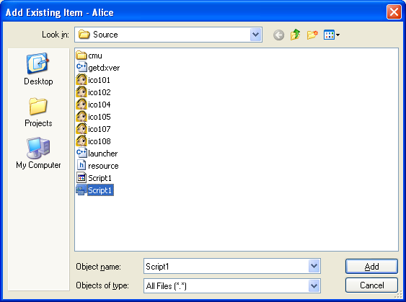
- Right click on your Alice project and click Properties.
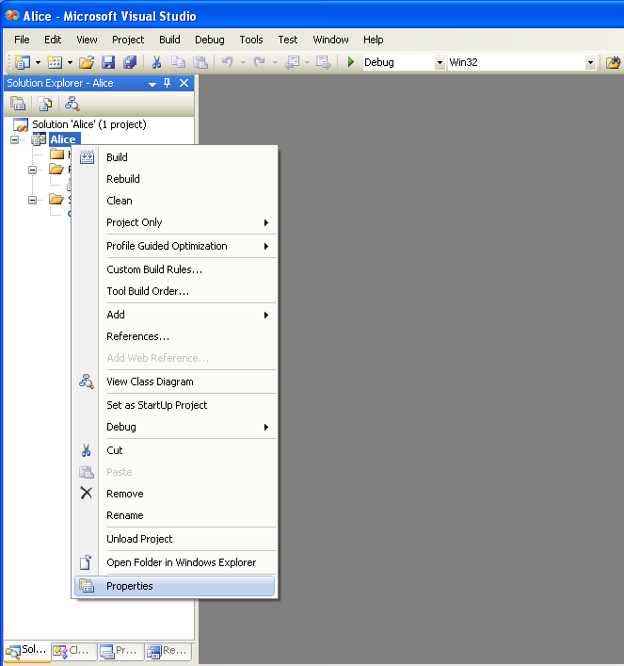
- In the Debugging section, change the Working Directory to the location of your Alice 2.2 folder.
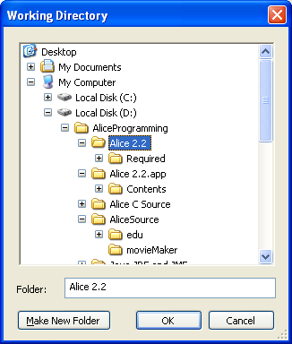
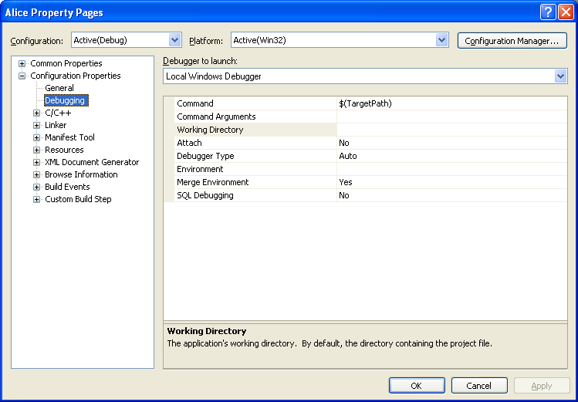
- In the C/C++, General section, include your Alice 2.2 source folder in the Additional Include Directories section. Your source folder contains two JNI header files that are required to compile your Alice 2.2 C++ project.
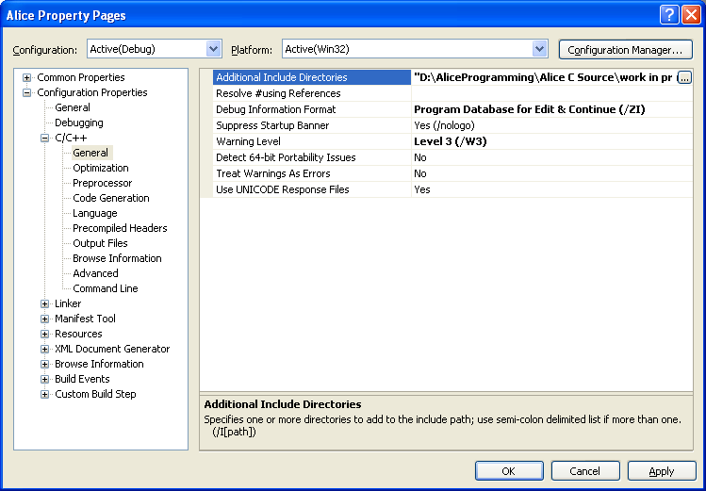
- Click the play 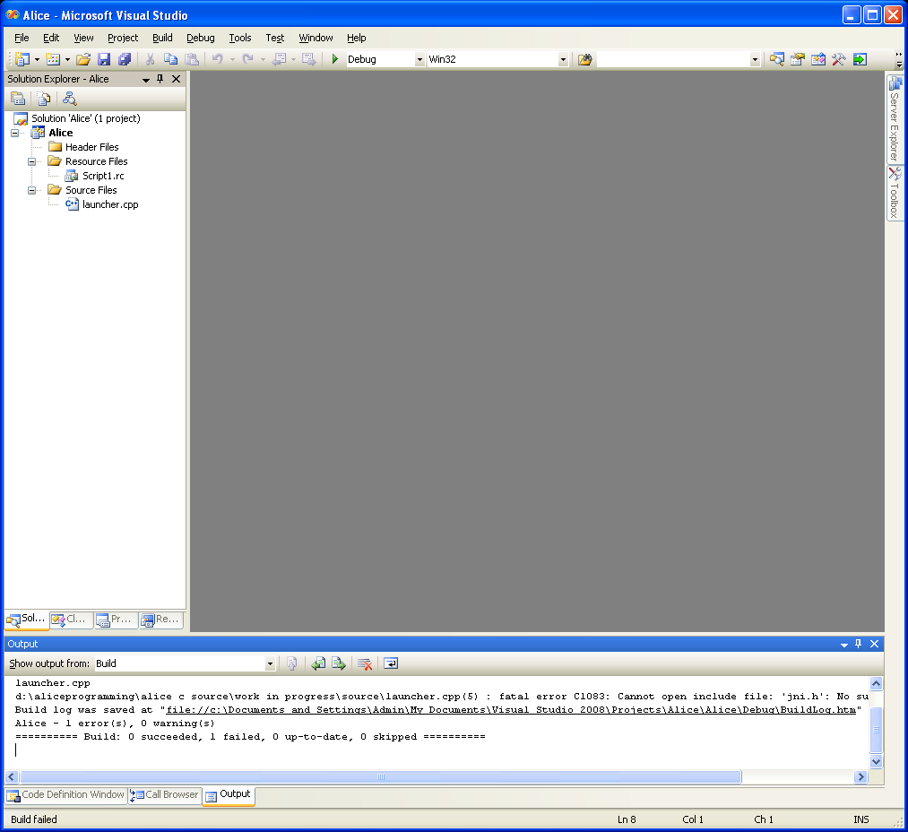 button to debug your project.
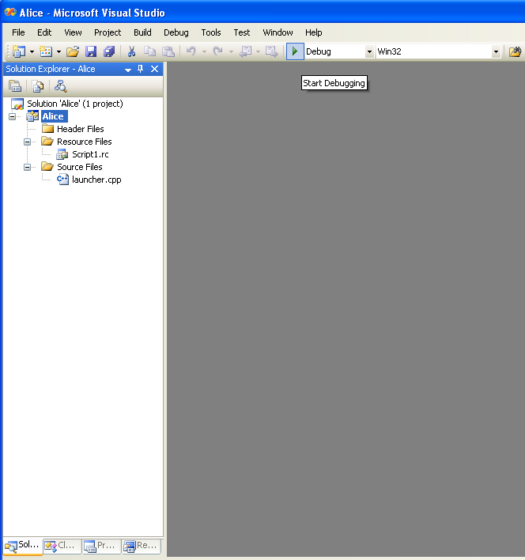
Editing a file
Note: Double click the file to edit
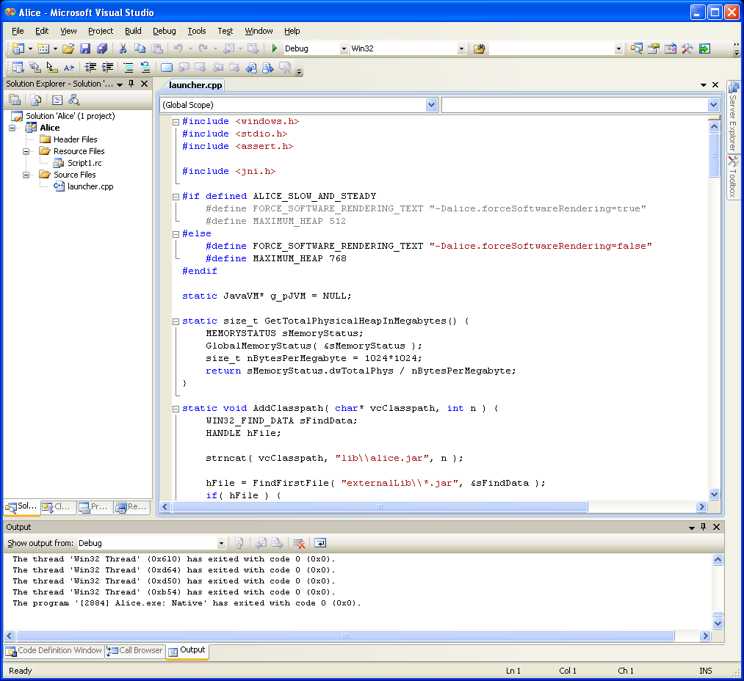
Editing the icon
Note: Double click on the Script1.rc file in the Resource Files folder. Double click on the file that you want to edit.
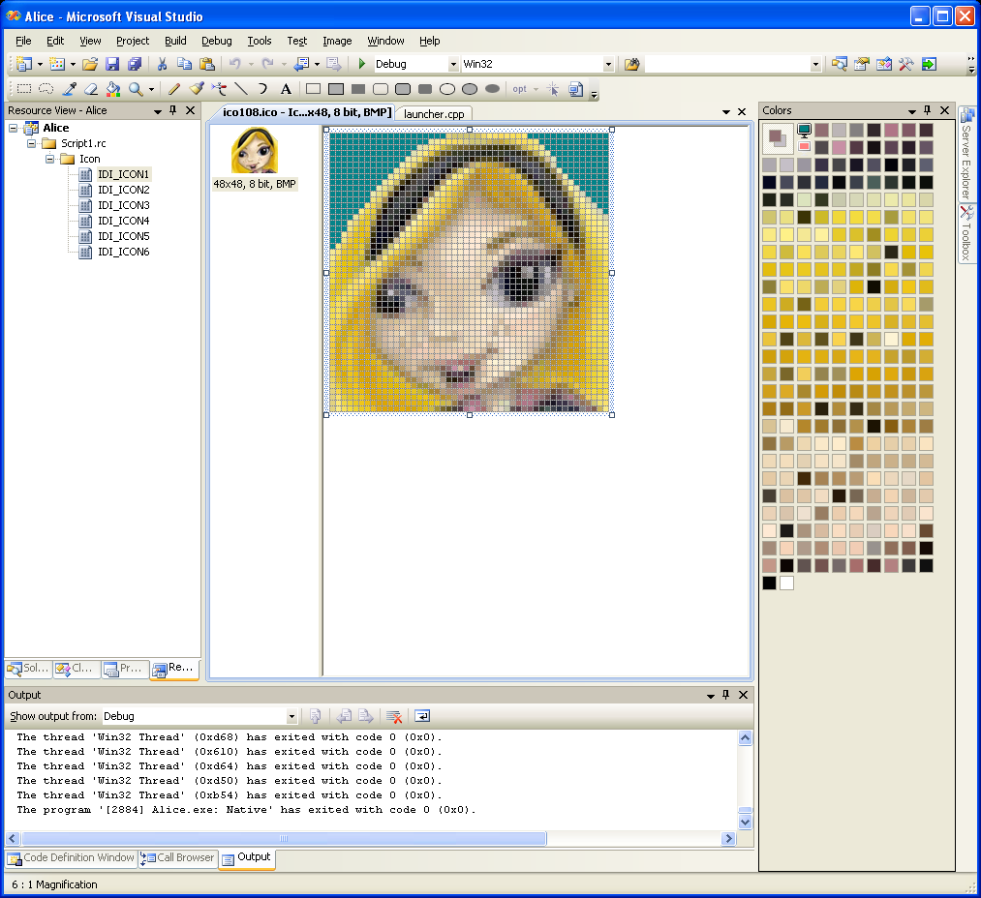
Enabling line number
Note: Go to Tools, and click Options. Check the Line numbers checkbox in the Text Editor, C/C++ section.
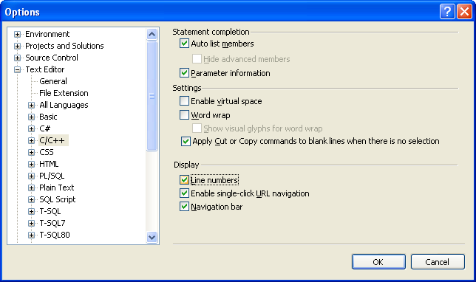
Changing configuration
Note: Use the Release configuration to create the final Alice.exe file. Create a ALICE_SLOW_AND_STEADY configuration to enable software rendering (See source code, line 7).
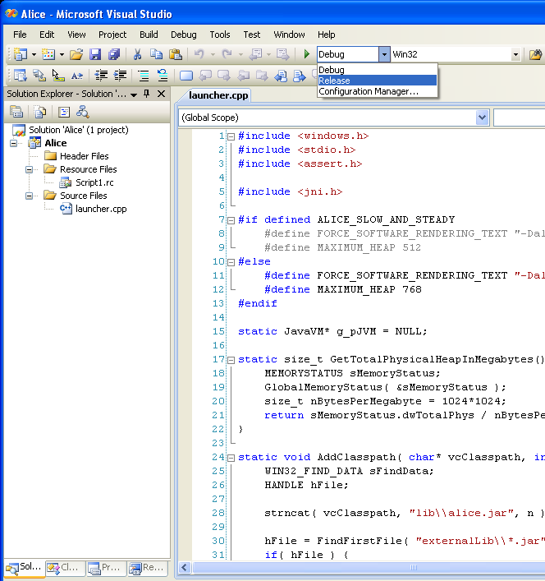
Editing the dlls

